3.1

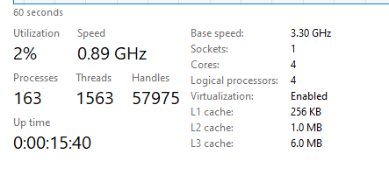

Installed RAM



Clock speed



Drives and drive types

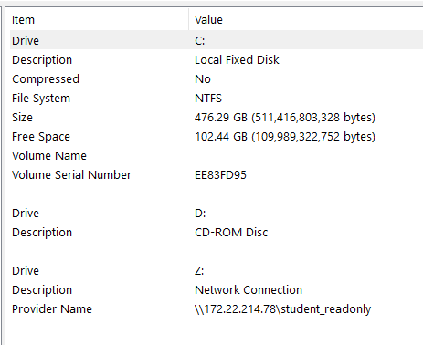

Number and types of interfaces 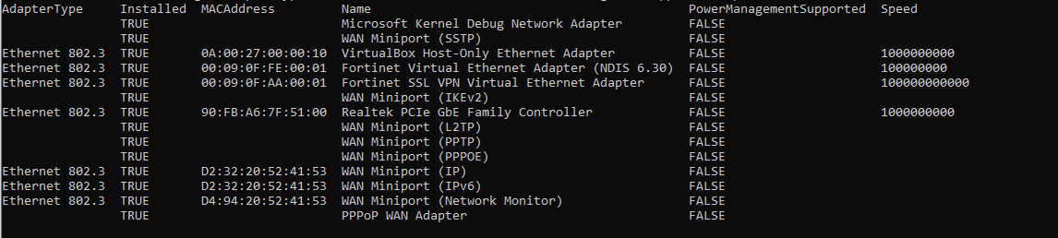

3.2 Main features of the OS

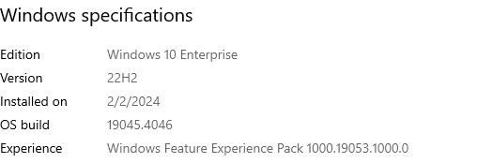

Number of processes



3.3

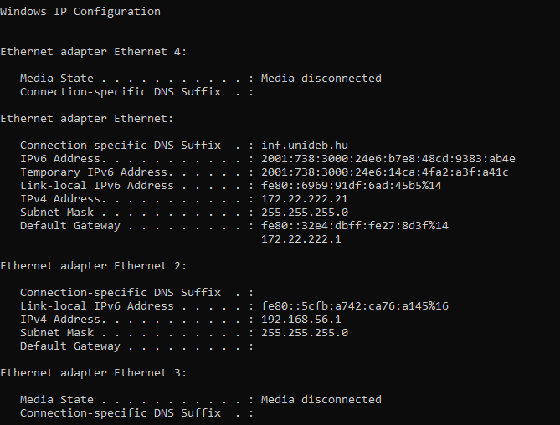

3.4

3.5

4.1

PC

Processor cores:4

Clock frequency: 3.30 x 10 power 6

Number and types of interfaces

B)

Mobile Redmi 10C

Cores 8

Clock frequency 2.40 X 10 power 6

Number and types of interfaces

4.2

Type: Windows

Version number: 22H2

Number of running processor cores



CPU load: 7%

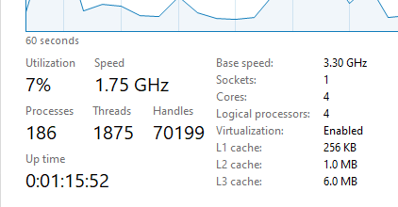

Mobile Redmi 10C

Type: Android

Version: Android 13

Running processes: Cover 1545 MB of RAM

CPU Load: 1545 MB = 43%

4.3